food ordering system

**Ashhad Khan 01-134221-109**

**Ahmed Shehzad 01-134221-010**

**Shahbaz Fareed 01-134221-072**

**BS(CS) – 4 A**

**DEPARTMENT OF COMPUTER SCIENCE**

**BAHRIA UNIVERSITY ISLAMABAD**

**section 1**

1. **INTRODUCTION:**

* Welcome to the future of online dining! Our Food Ordering System Project is a testament to the seamless integration of HTML, CSS, PHP, and dynamic databases, offering a streamlined and user-friendly solution for ordering delicious meals online. Designed to cater to the modern, fast-paced lifestyle, this project not only showcases our prowess in web development but also revolutionizes the way we engage with food services. Join us in exploring the simplicity, efficiency, and flavor-packed experience that our system brings to the table. Get ready to indulge in a world where technology meets taste, making your food ordering process a breeze.

1. **domain intro:**

* Step into a world of culinary convenience with our Food Ordering System Project! Our domain is a digital haven where the savory meets the virtual, showcasing the perfect synergy of HTML, CSS, PHP, and dynamic databases. This space is dedicated to providing a swift and efficient platform for users to explore, order, and relish delightful meals from the comfort of their screens. Join us as we navigate this delectable journey through technology and taste, bringing you a seamless online dining experience like never before. Welcome to the intersection of flavor and functionality!

1. **scope:**

* The Food Ordering System Project encompasses a comprehensive scope, aiming to redefine the way users interact with online dining experiences. Key components of the project include:

1. **User-friendly Interface:** The project prioritizes a sleek and intuitive user interface designed using HTML and CSS. Navigating through the system is made effortless, ensuring a pleasant experience for users of all backgrounds.
2. **Order Management System:** The system facilitates seamless order processing, allowing users to browse diverse menus, add items to their cart, and proceed through a hassle-free checkout process. Order management features are implemented for both customers and administrators to track and manage orders efficiently.
3. **Dynamic Database Integration:** Leveraging PHP, the project integrates dynamic databases to provide real-time updates on menu items, prices, and availability. This ensures accuracy and reliability in displaying the latest information to users.
4. **User Authentication and Personalization:** To enhance user experience, the system incorporates secure user authentication mechanisms. Registered users can personalize their profiles, track order history, and save preferences for a more tailored and convenient ordering process.
5. **Payment Integration:** The project supports secure payments, incorporating payment gateway integration. This ensures that users can make payments with confidence, contributing to a seamless end-to-end process.
6. **Responsive Design:** The system is developed with a responsive design approach, ensuring compatibility across various devices, including desktops, tablets, and mobile phones.
7. **Scalability:** The project is designed with scalability in mind, allowing for easy expansion, addition of new features, and integration with a growing number of restaurants and users.

In essence, the Food Ordering System Project aspires to provide a robust, user-centric, and scalable solution, bridging the gap between technology and the culinary world to deliver a delightful online dining experience.

1. **objectives:**

* The Food Ordering System Project seeks to elevate the online dining experience by streamlining the ordering process with a user-friendly interface, incorporating real-time updates through dynamic databases, and enhancing user engagement with secure authentication and personalization features. The project also aims to empower restaurant owners with an efficient control panel for seamless menu management, order tracking, and business insights. With the integration of reliable payment gateways, responsive design for accessibility across devices, and scalability to accommodate future growth, the project aspires to provide a secure, efficient, and enjoyable platform that bridges the gap between technology and the culinary world.

1. **technologies:**

* The front-end employs HTML and CSS to craft a sleek and intuitive user interface, ensuring a seamless browsing experience. PHP serves as the dynamic server-side scripting language, facilitating real-time updates through integration with MySQL, which functions as the database management system. XAMPP, a cross-platform web server solution, is utilized to create a local development environment, combining Apache as the web server component to interpret and execute PHP scripts. This local server setup provides a secure testing ground for the project before deployment. The implementation of responsive design principles ensures accessibility across a spectrum of devices, while the integration of secure payment gateways enhances transaction reliability. Together, these technologies harmonize to deliver a robust, secure, and user-centric Food Ordering System.

**section 2**

1. **Database design:**

entities: booktable, cart, customer, menu, all_sales

attributes:

* Booktable:
* ID
* Name1
* Phone
* email
* persons
* date1
* CART:
* ITEM
* DESCRIP
* PRICE
* CUSTOMER:
* ID
* FIRSTNAME
* LASTNAME
* EMAIL
* PHONE
* USERNAME
* PASWORD
* MENU:
* fname
* descrip
* price
* ALL_SALES:
* ITEM
* DESCRIP
* PRICE

1. **entities description:**

* The "BOOKTABLE" entity stores information about table reservations, including the customer's name, contact details, the number of persons in the party, and the reserved date. It uniquely identifies each reservation with an ID.
* The "CART" entity represents items selected by a customer for purchase. It includes details such as the item name, description, and price, offering a snapshot of the customer's shopping cart.
* The "CUSTOMER" entity stores information about customers, encompassing personal details, contact information, and login credentials. Each customer is identified uniquely by their ID.
* The "MENU" entity represents menu items offered by the restaurant. It includes details such as the item name, description, and price, allowing the system to manage and display available food options.
* The "All_Sales" entity in the Food Ordering System's captures crucial details for each sale, including the sold item ("Item"), its description ("Descrip"), and the corresponding price ("Price"). This entity plays a central role in tracking and managing sales transactions within the system.

1. **erd diagram and description:**

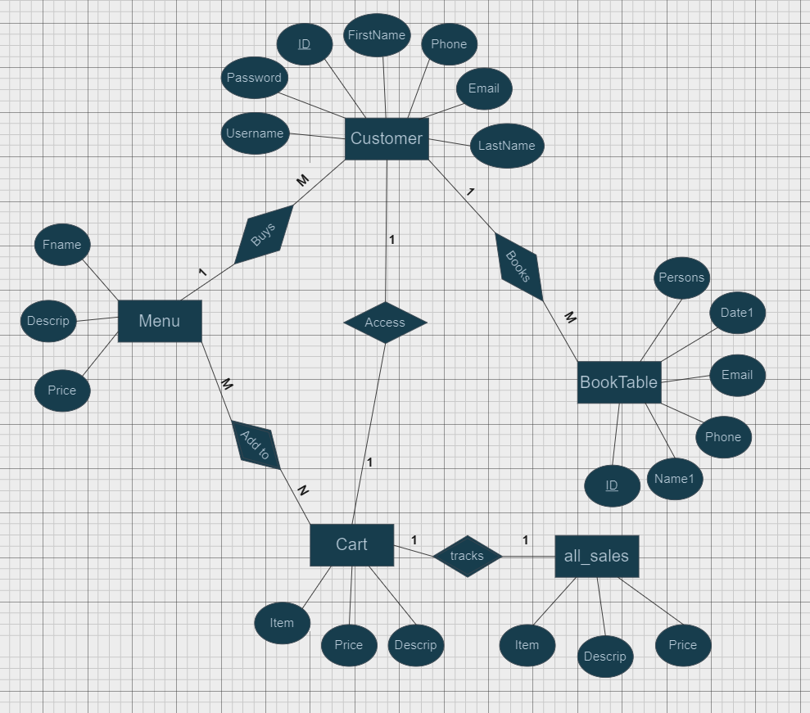

* The Food Ordering System's ERD comprises key entities: "Customer" (CustomerID, Name, Contact, Credentials), "Menu" (FoodID, Name, Description, Price), "BookTable" (BookingID, Customer details, ReservationDate), "Cart" (ItemID, Description, Price), and "All_Sales" (Item, Descrip, Price). Relationships include a one-to-many link between customers and table bookings, and a many-to-many association between customers and their shopping carts. The "All_Sales" entity plays a central role in tracking and managing sales transactions, capturing crucial details for each sale within the system. This structure forms a concise and comprehensive data model for the Food Ordering System.

1. **rELATIONAL DIAGRAM AND DESCRIPTION:**

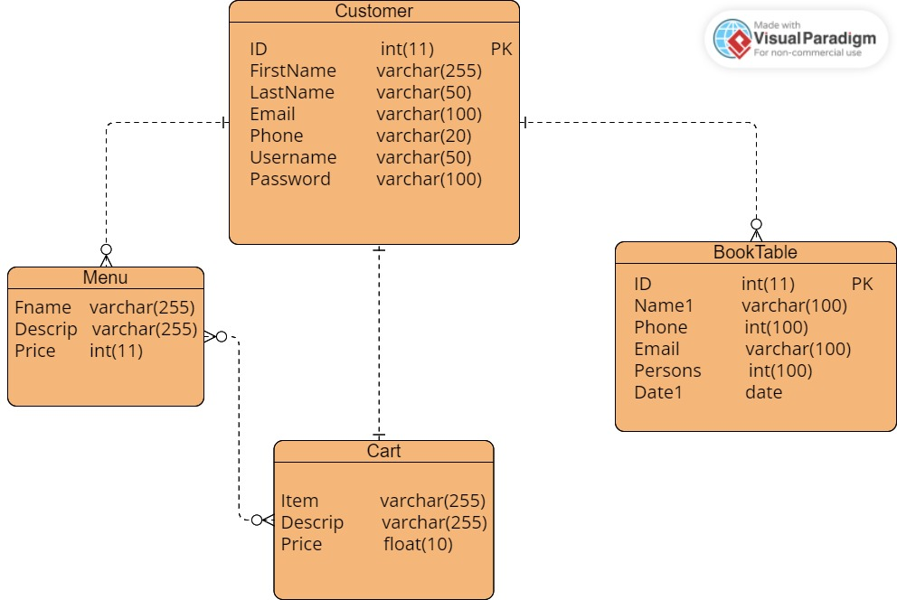

* The relational database for the Food Ordering System consists of several key tables. The "Customer" table stores information such as customer ID, name, contact details, and login credentials. The "Menu" table holds details about the available food items, including their names, descriptions, and prices. The "BookTable" table manages reservations with fields like booking ID, customer details, and reservation date. The "Cart" table facilitates the ordering process, containing information on items selected by customers, such as item ID, description, and price. These tables establish relationships, such as a one-to-many connection between customers and table bookings, and a many-to-many relationship between customers and their shopping carts, providing a comprehensive structure for the Food Ordering System's data management.

**section 3**

1. **sAMPLE SS OF FRONTEND WITH EXPLANATIONS AND CAPTIONS:**

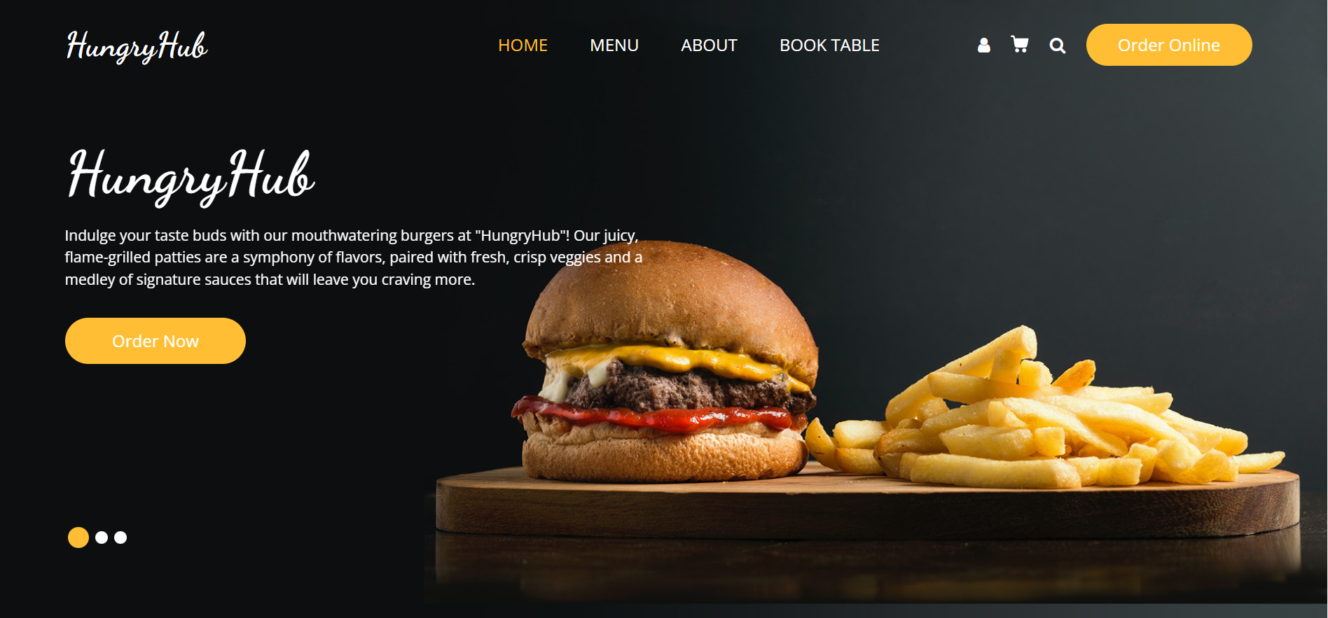

* The home page features banner adorned HungryHub's vibrant branding, enticing users to savor the moment and explore the diverse culinary offerings. HungryHub ensures an intuitive navigation experience, guiding users effortlessly through a well-organized interface. From exploring menus to managing orders, the platform makes the culinary journey both exciting and convenient.

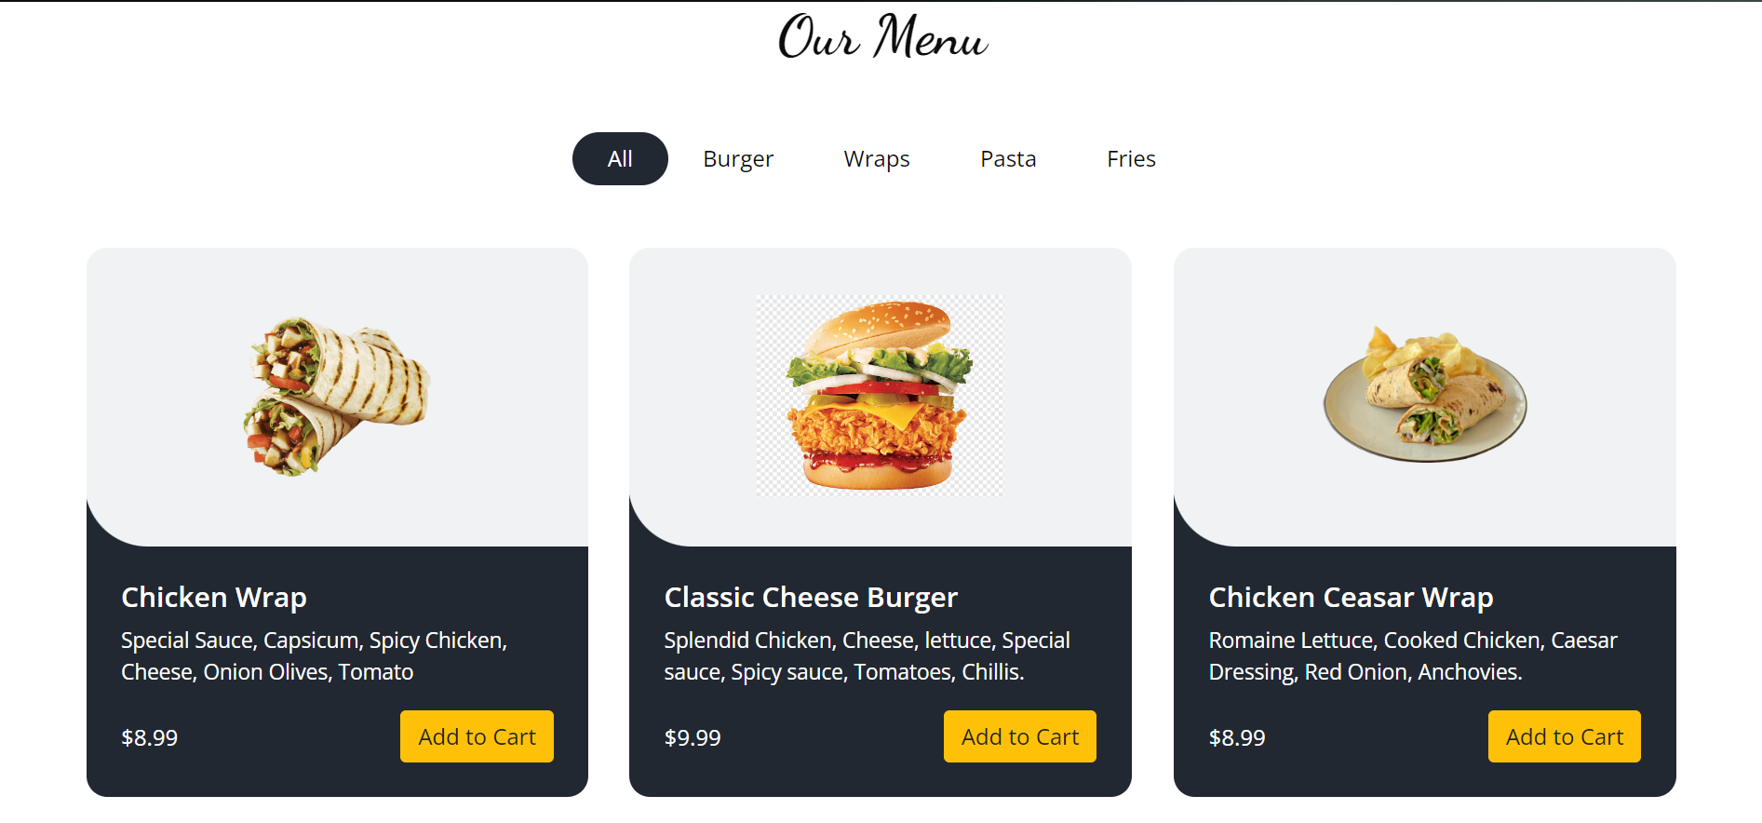

* HungryHub's Menu page is a visual delight, presenting a diverse array of culinary delights to suit every taste. Each dish, accompanied by enticing visuals and detailed descriptions, offers a tantalizing preview of the flavors in store. With transparent pricing and a user-friendly interface, the Menu page ensures clarity in every byte, empowering users to make informed choices while staying within their budget. The seamless integration of an "Add to Cart" button enhances the overall ordering experience, allowing users to compile their selections effortlessly. HungryHub transforms the act of ordering into a flavorful journey with its curated menu and user-centric features.

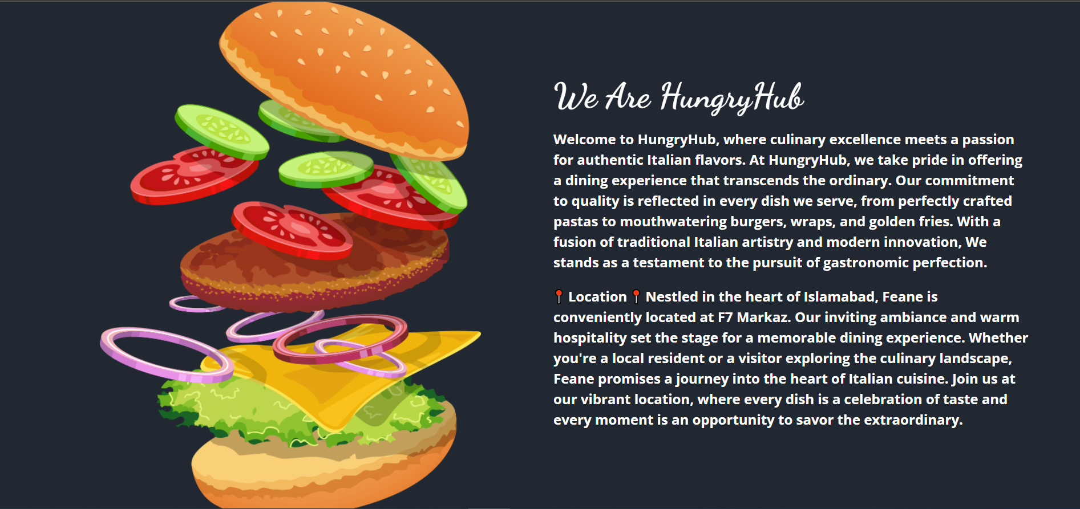

* The About page at HungryHub invites users to explore the rich tapestry of our culinary journey. From the roots of our inspiration to the commitment to culinary excellence, each section paints a vivid picture of what sets HungryHub apart. Discover the faces and stories that bring HungryHub to life, making it not just a platform but a community united by a love for great food and memorable dining experiences.

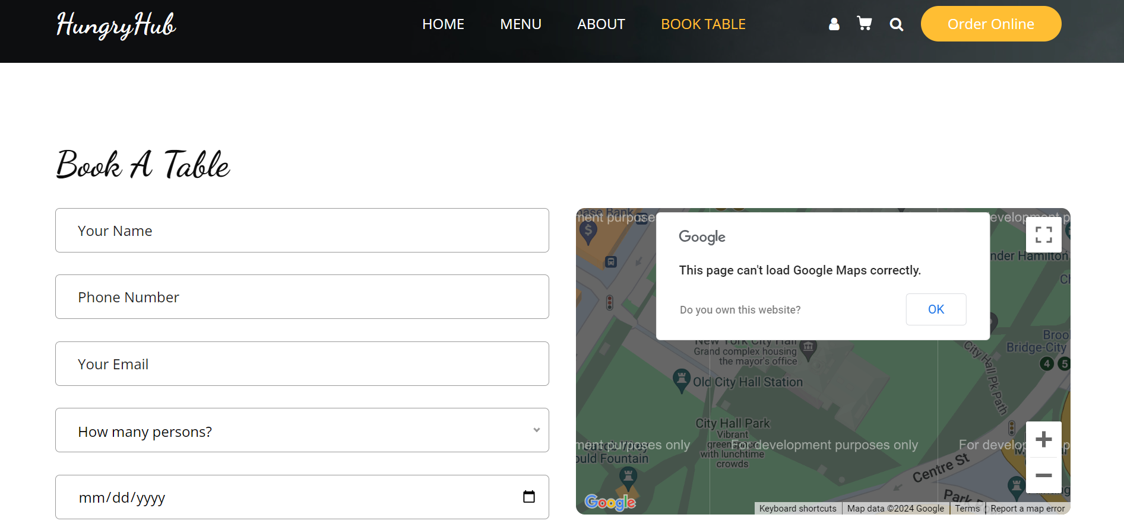

* HungryHub's Book Table page is your personalized gateway to an exceptional dining experience. Seamlessly blending convenience with elegance, this feature allows users to reserve tables effortlessly for a memorable culinary journey. The intuitive interface captures essential details like name, contact information, persons, and preferred date, ensuring a seamless booking process.

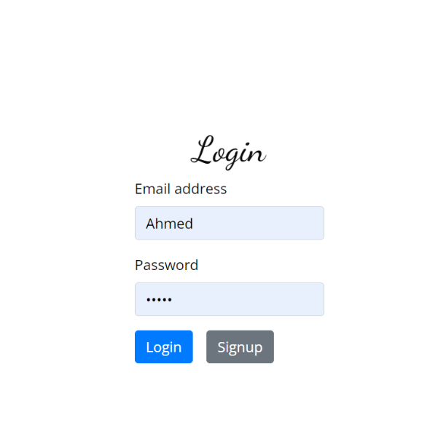

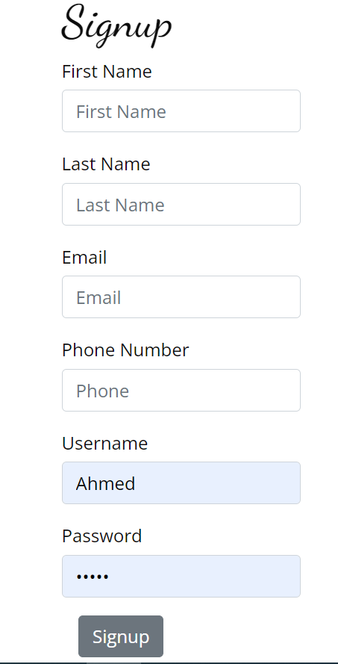

* HungryHub's Login and Signup pages are the gateways to a personalized culinary adventure. The Login page offers a secure portal for returning users to access their accounts with ease, ensuring a seamless experience with every visit.

1. **back-end basic php functions and explanation of tasks:**

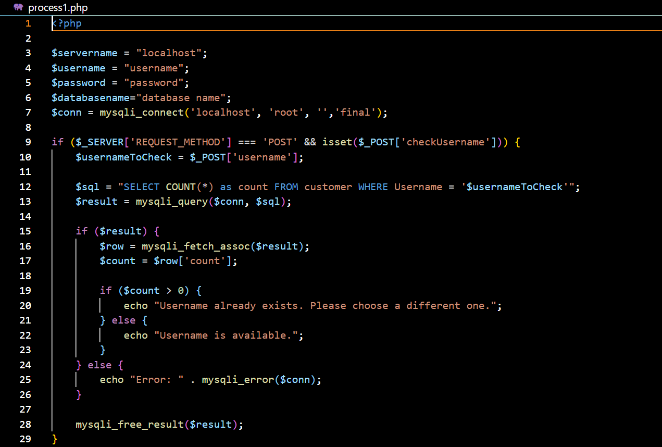

* The backend code for 'process1' in HungryHub's Food Ordering System handles user registration and username availability verification. It establishes a connection to the database, checks if a provided username already exists, and responds dynamically to inform users about the availability status. Additionally, the code captures user input for registration, sanitizes it, and inserts the data into the 'customer' table.

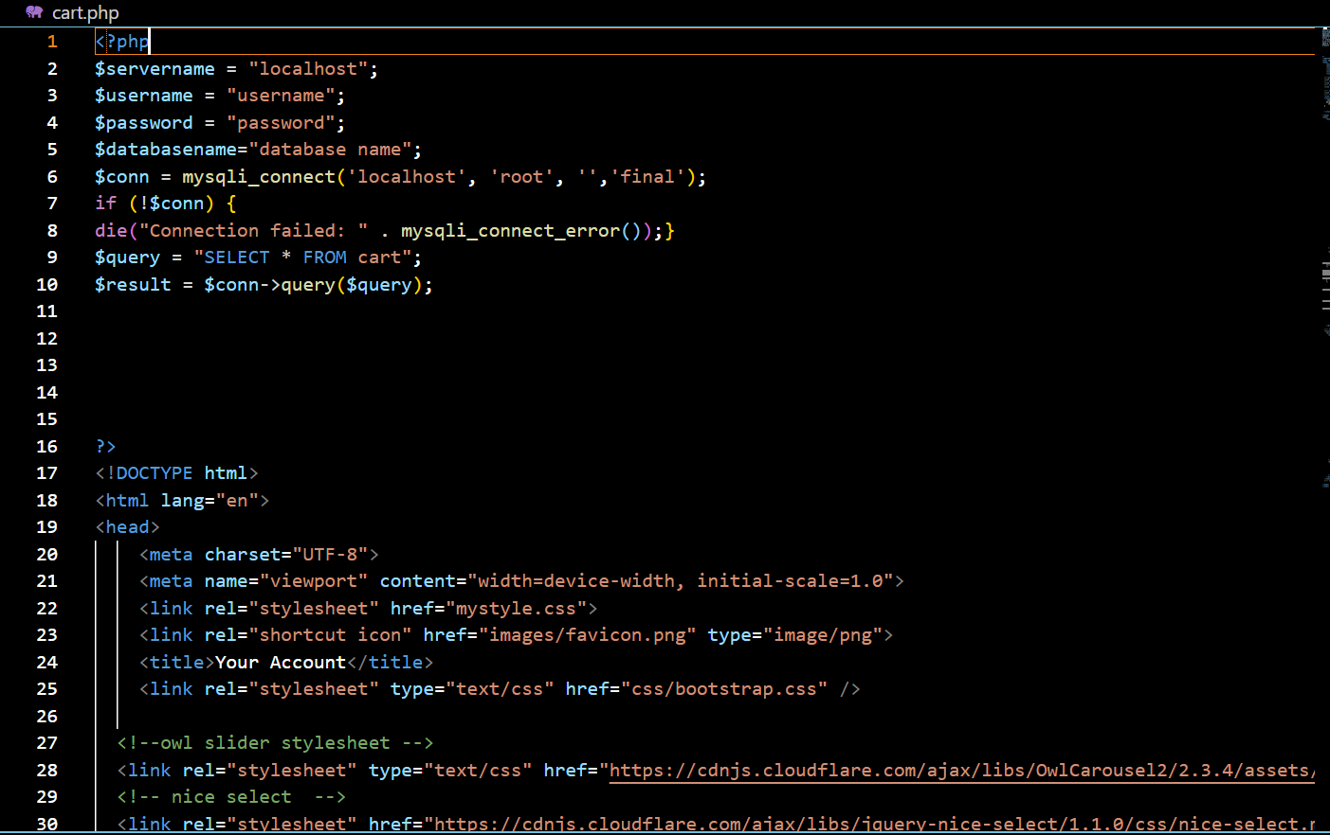

* This PHP and HTML code powers the 'cart.php' page in HungryHub's Food Ordering System. It connects to the database, retrieves cart details, and dynamically displays items, descriptions, and prices. The page calculates and presents the total cost, offering users a clear overview of their order. The 'checkout' button directs users to 'delete.php' for finalizing purchases. With responsive design and navigation, this code streamlines the user experience, facilitating a seamless interaction with the cart and checkout process.

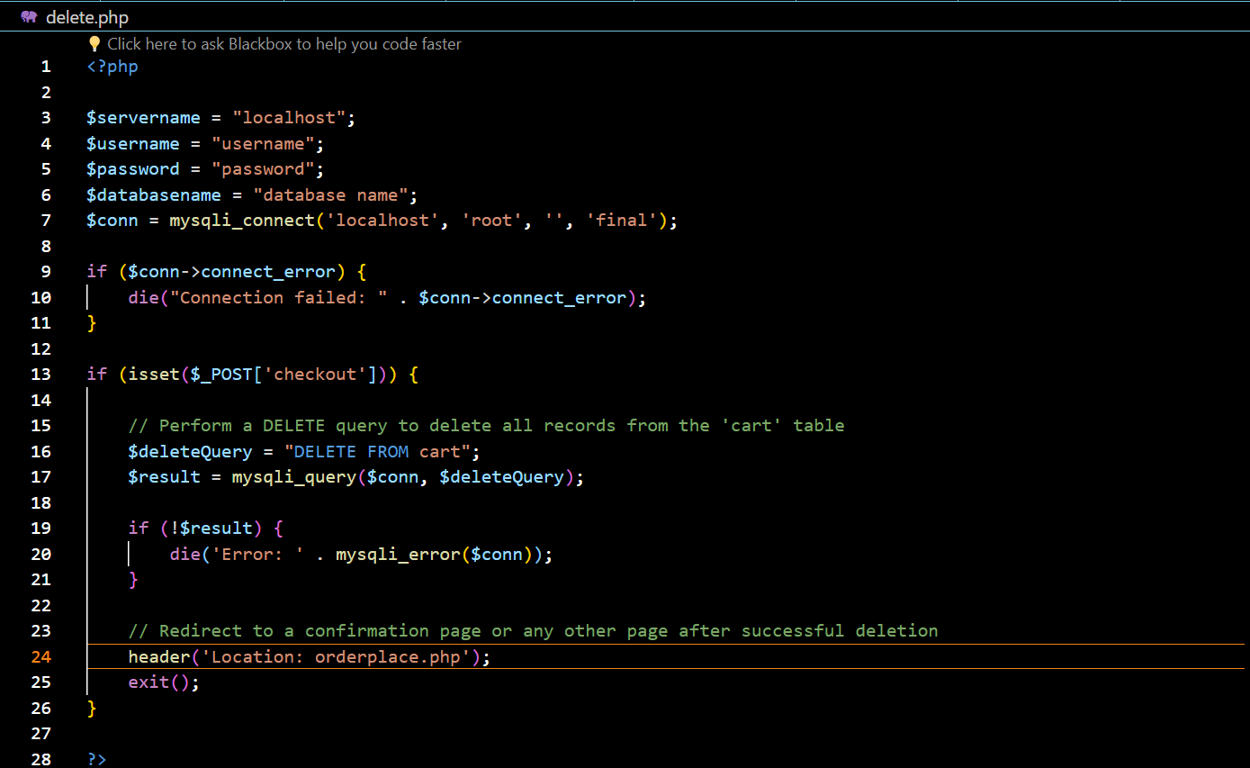

* This PHP and HTML code powers the 'cart.php' page in HungryHub's Food Ordering System. It connects to the database, retrieves cart details, and dynamically displays items, descriptions, and prices.

1. **HTML/CSS code important chunks and descriptions:**

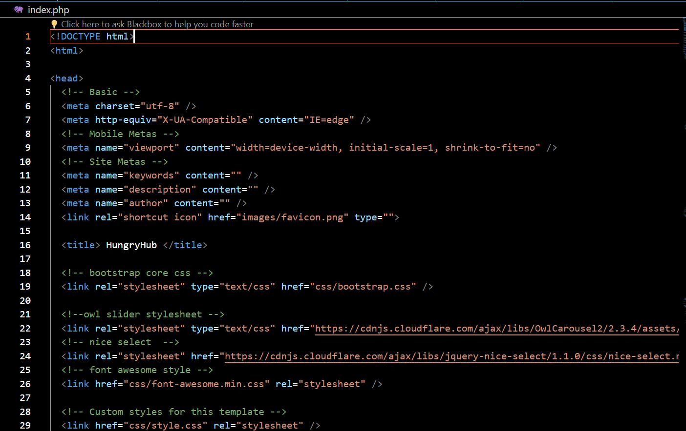

* The 'index.php' file in HungryHub's Food Ordering System project serves as the main entry point, featuring a well-designed navigation bar that directs users to key sections like Home, Menu, About, and Book Table. The page seamlessly integrates branding elements and offers an intuitive user experience. With a responsive design, engaging visuals, and easy access to essential functionalities, 'index.php' establishes a visually appealing and user-friendly interface, setting the tone for a delightful culinary exploration on the platform.

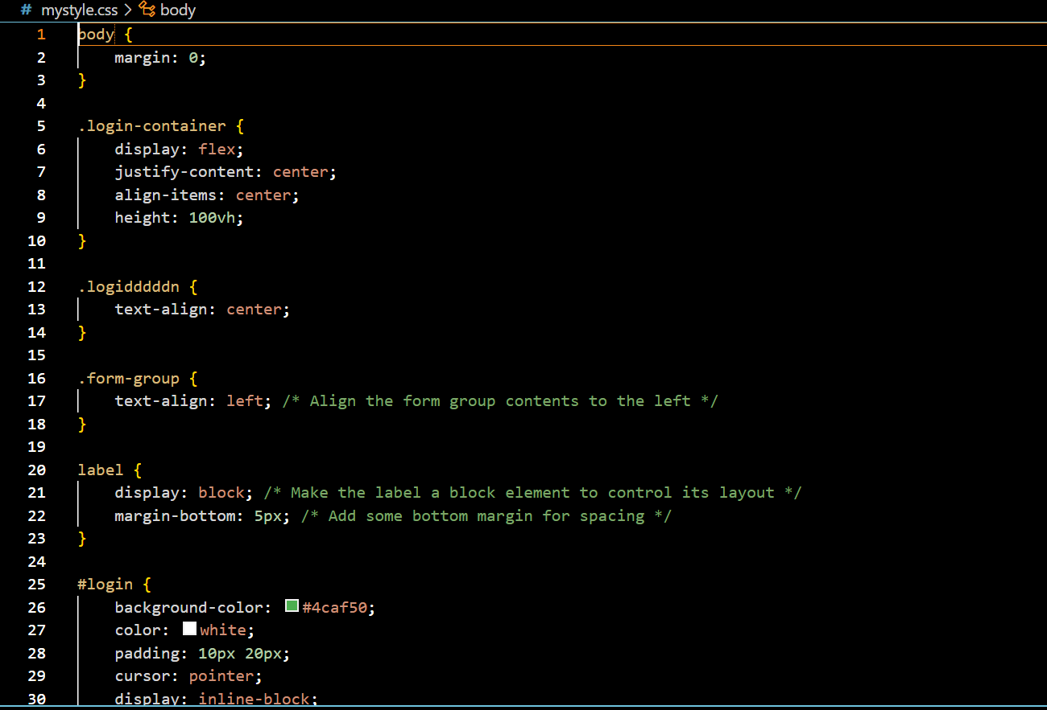

* The CSS styles define the visual aspects of HungryHub's Food Ordering System, ensuring a clean interface with a responsive login/signup layout, centered containers, and consistent button designs.

**section 4**

1. **bASIC INSTALLATION STEPS OF VS CODE AND XAMPP:**

* Download VS Code: Go to the official Visual Studio Code website at <https://code.visualstudio.com/download> and click on the "Download for [Your Operating System]" button.
* Install VS Code: Once the installer is downloaded, run the installer and follow the on-screen instructions for your specific operating system (Windows, macOS, or Linux).

**XAMPP:**

* Download XAMPP: Visit the official XAMPP website at <https://www.apachefriends.org/index.html> and download the version suitable for your operating system (Windows, macOS, or Linux).
* Run the Installer: Once the installer is downloaded, run it to start the installation process.
* Follow Installation Wizard: The XAMPP installation wizard will guide you through the installation process. Follow the on-screen instructions. You may be prompted to choose components to install; typically, Apache, MySQL, and PHP are selected by default.

1. **Link to the code:**

* Github link to the code: <https://github.com/AshhadKhan889/HungryHub>